Guideline for abstracts prepared for the International Conference on Science, Technology and Education 2024 (Time New Roman 14)

1. Firstauthor1, B. Seconduathor2 and C. Thirduathor3

1 King Mongkut's University of Technology Thonburi, 126 Pracha Uthit Rd., Bang Mod, Thung Khru, Bangkok 10140, Thailand

2Author Affiliation

3Author Affiliation

Correspondence E-mail: author@education.ac.th

Abstract

This document is prepared to present the sample format for the **ICSTE2024** abstract submission (within 2 pages). Prospective authors are invited to submit extended abstracts.  Each submission is limited to 2 pages in length and should be formatted in a two column format (in 10 point and single spaced).  The paper should be submitted either in MS Word or PDF formats and should be written in English.  Abstracts can be electronically submitted only at https://etete.org/paper_submission/author/php/index.php After the review process, the accepted authors should submit full papers within four pages.

**Keywords:** *keyword 1, keyword 2, keyword 3 (List three to five pertinent keywords specific to the manuscript)*

# 1. Introduction (General information)

These guidelines are prepared to present the sample style for the **ICSTE2024** abstract submission. All manuscripts must be written in English.

Contributed papers should be comprised of the following sections:

* Introduction
* Experiment
* Results and Discussion
* Conclusion

# 2. Experiment (Paper format)

The size of the manuscript must be Letter or A4 and it should be typed in two columns with single spacing. The following margins are recommended.

Table 1: Front faces to be only used in the abstracts for ICSTE 2024.

|  |  |
| --- | --- |
| **Element** | **Front face and size** |
| Title | Times 14, bold |
| Authors’ name | Times 10, normal |
| Affiliations | Times 12, normal |
| Main text | Times 10, normal |
| Major headings | Times 12, bold |

# 3. Results and Discussion (Main text)

The first part includes the paper title, authors’ name, abstract, and keywords. All fonts must be in Times New Roman.

The main title (on the first page) should begin about 3.5 cm from the top edge of the page and should be centered (14-point and boldface). Leave two blank lines after the title.

3.1 Figures

Abstracts should include one figure.

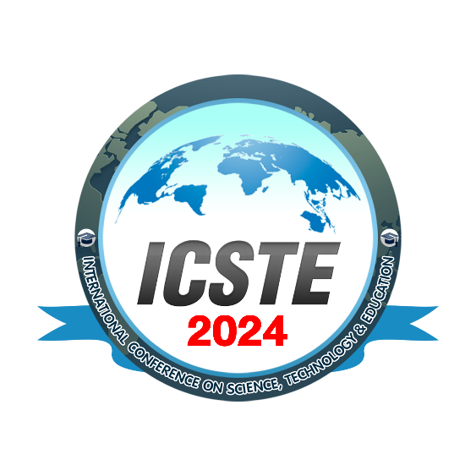

**Figure 1.** An example of a figure.

# 4. Conclusion

The authors should discuss the results and how they can be useful in the future.

**Acknowledgements**

The authors should acknowledge any support given which is included in funding.

# References

References should appear in a separate bibliography at the end of the manuscript, with items referred to by numbers in square brackets [1, 2-4]. Times New Roman 10pt is recommended for references.

[1] A. Kim, B. Lee, and C. Park, “Article Title”, *Journal name*, Vol. 1 (no. 2), pp. 1-10, 2005.

[2] J. Martinez, K. Johnson, and C. Dean, “Chaper Title”, In *Book Title*, Publisher, pp. 1-10. 2008.